National Bureau of Economic Research (NBER)
Name
Institution
Date

National Bureau of Economic Research (NBER)
Introduction
The National Bureau of Economic Research is an American private nonprofit research organization. NBER is wholly committed to carrying out as well as distributed unbiased economic research targeting the public policymakers, business professionals as well as the academic community. It is distinguished by its ability to provide United States' significant dates concerning the recessions.
NBER’s programs research activities are divided into 20 research programs with distinct subjects as well as 14 working groups. The research groups include; public Economics, Aging, industrial organization, productivity, Economic fluctuations and Growth, Children, political Economy, Asset pricing, law and Economics, Behavioral/macro, International Finance and Macroeconomics, Health care, Health Economics, Development of the American Economy, Monetary Economics, Industrial Organization, International Trade and Investment, Capital Markets and the Economy, Corporate Finance, Energy and the Environment, Labor Studies, Economic Fluctuations and Growth and Economics of Education. These research frameworks are utilized in drafting NBER’s work mg papers.
NBER’s Business Cycle Dating Committee of the National Bureau of Economic Research
The committee suggests a chronology of the U.S. business cycle consists of dates mainly on the peaks as well as troughs in any given economic activity under investigation. The recession period is defined as the period occurring between the trough and a maximum. In the recession period, the economic activities are usually spread and exhibit a declining trend typically lasting a few months or even a year. Om the other side, an expansion is described by a significant rise in the economic activities spread in the economy lasting for several years.
NBER’s business cycle may depict both the expansions and recession trends. Brief reversals usually indicate it in the economic activity that happens within the economy. The recession often includes a short period of extensions while the periods of decline are inevitable in the economy though it may take a smaller amount of time. It is the responsibility of the committee to utilize judgement that is dependent on the concepts of recessions as well as expansion. It does not have fixed rules and regulations to assist in determining if the contraction is for only a short interruption of an increase or if the judgement was ultimately based on the disruptions occurring due to the interruption of contradiction. For instance, in the year 1980 -1982, there was a jug dement passed by the committee in which a contraction that started in 1981 and which was not presumably based on the continuation that had previously occurred in 1980 hence depicting a separate full recession. Figure 1 illustrates the economic slowdown in the united states between 2007 and 2010.
Figure 1 Economic Recession and Recovery from 2007 to 2010
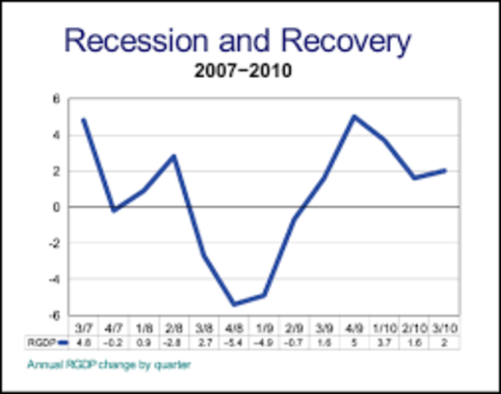
Source: https://www.google.com/search?q=last+recession+in+the+united+states&rlz=1C1CHBF_en&sxsrf=ACYBGNS9AZsQVnRsNeKQkX7bF-PDpH1Zaw:1576766095866&tbm=isch&source=iu&ictx=1&fir=NUWaiFLCwSM9LM%253A%252CmwiT_jKnIOEbsM%252C_&vet=1&usg=AI4_-kQtRHNQtgZZ5dIxhzrH7VQdcdzDgA&sa=X&ved=2ahUKEwjBxqa498HmAhW-A2MBHfBHCGoQ9QEwAHoECAoQAw#imgdii=NrzCMN_NgzapdM:&imgrc=NUWaiFLCwSM9LM:&vet=1
The committee jurisdiction is limited since there is no fixed definition of economic activities. It is the central role entails making a comparison based on the numerous metrics concerning the large business. For instance, the real GDP is measured through analysis of the product as well as income sides, real income, and economy-wide employment. Furthermore, the committee usually has to make a comparison on the indicators that have little impact on the entire economy that include the real sales as well as the federal reserve index of the industrial production (IP). The committee such indicators alongside the broad aspects that allow for recognition of double-counting of sectors that are included in those indicators as well as the general measures. Furthermore, a well-defined peak or trough is targeting the real sales or even the IP could be used to determine the overall height and trough dates, respectively. This is witnessed, especially when the economy-wide indicators are not in agreement or even have undefined peaks and troughs.
The Great Recession in the United States
NBER declared she made a declaration that united states had entered an economic recession in the year 2007 in December (figure 2). An adverse financial crisis depicted this recession, not just in the united states but across the entire globe. The recession lasted between December 2007 to June 2009. Consequently, it took a couple of years before the economy could recover to the pre-crisis levels of employment and overall output of production.
Figure 2: Recession in the united states in December 2007.
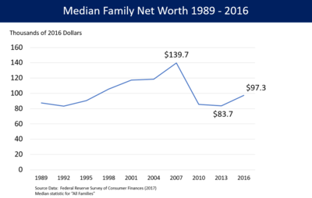
Source: https://www.google.com/search?q=last+recession+in+the+united+states&rlz=1C1CHBF_en&sxsrf=ACYBGNS9AZsQVnRsNeKQkX7bF-PDpH1Zaw:1576766095866&tbm=isch&source=iu&ictx=1&fir=NUWaiFLCwSM9LM%253A%252CmwiT_jKnIOEbsM%252C_&vet=1&usg=AI4_-kQtRHNQtgZZ5dIxhzrH7VQdcdzDgA&sa=X&ved=2ahUKEwjBxqa498HmAhW-A2MBHfBHCGoQ9QEwAHoECAoQAw#imgrc=NUWaiFLCwSM9LM:&vet=1
The 2007-2010 financial crisis recovery was attributed to the fact that a considerable number of households as well as financial institutions took advantage and to make payments in advances that accumulated over the years before the crisis. The US government’s expenditure was restricted alluded to the initial stimulus efforts effectively happened. After that, the bursting of the housing bubble, the housing market correction, as well as the subprime mortgage crisis.
The causes of the Great recession
According to the federal reserve that was testified by its chair in September 2010, the crisis emanated from the economic shocks that had triggered some events alongside numerous vulnerabilities occurring in the financial system and regulations that exacerbated the clashes. Some of the economic shocks the promulgated the financial crisis is the losses based on the subprime mortgage securities that commenced in the year 2007. They continued to operate in the shadow banking system from as early as mid-2007. Consequently, they, directly and indirectly, influenced the banking monetary instruments balances in the money markets. For instance, some vulnerabilities in the private sector incorporated the financial institution that depended entirely on the unstable sources of short-term funding with significant emphasis on the repurchase agreements. Some deficiencies existed in the risk management frameworks failing to identify the risks and mitigate them on time (Chen et al., 2015).
The economy comprised of the excessive utilization of the leverage, which included the borrowing intending to invest. The economic recessions reduced the purchasing power of the consumers. The investors who had heavily borrowed primarily for investment experience the economic shock. This is because, even though the firms had goods and services, the customers lacked adequate monetary resources to make purchasing decisions. Some of the investors were forced to foreclosure their business since the costs were accumulating, and the company was not making revenues sufficient to remedy the situation.
Before the 2007 financial crisis, some specific quotas had utilized derivatives inappropriately. Some of the investors had foreshadowed that the economic boom was likely to be witnessed hence ended up taking excessively higher risks that jeopardized the money market. This meant that the regulators were ultimately left to make decisions that would correct the financial mistakes made (Dufour and Orhangazi 2016).
Their economic recession was spearheaded by the subprime crisis that entailed a massive influx of monetary instruments into the economy from the private sectors. Moreover, financial institutions, such as the banks were slowly entering the mortgage bond market. This means that their monetary instruments were readily available hence distorting their balance in the economy. The government policies were also enacted with the primary objective of homeownership expansion project as well as the speculations emanating from numerous existing and potential home buyers. Lastly, the financial institutions, especially the mortgage facilities, were readily available, and people would access the facility to purchase the house. The mortgages allowed for the risk adjustments based on the mortgage rate, which ranged from 2-28 per cent. Also, mortgage lenders sold directly and indirectly by incorporating mortgage brokers (Lewin, Watson, and Brown, 2018).
The government policies also played an essential role in the great recession of the united states in the year 2007 and 2008. The federal inquiry explained that some national policies were responsible for a large exited for the downturn of the united states and the looming unemployment in the county. The non-depository banking system was not ultimately subjected to the risking taking regulations as their counterparts the depository banks. They play a massive role in the distribution of monetary instruments through issuing loans and allowing potential investments to purchase the shares. Some of the top investment's banks surrounding the crisis included the Lehman Brothers, Merrill Lynch, The Goldman Sanchs and Morgan Stanley that an accumulation of over $ 4 trillion in debt in 2007 when the financial crisis cloaked.

References
Chen, T., So, E. P. K., Wu, L., & Yan, I. K. M. (2015). The 2007–2008 US Recession: What Did the Real‐Time Google Trends Data Tell the United States?. Contemporary Economic Policy, 33(2), 395-403.
Dufour, M., & Orhangazi, Ö. (2016). Growth and distribution after the 2007–2008 US financial crisis: who shouldered the burden of the crisis?. Review of Keynesian Economics, 4(2), 151-174.
Lewin, P. A., Watson, P., & Brown, A. (2018). Surviving the Great Recession: the influence of income inequality in US urban counties. Regional Studies, 52(6), 781-792.

